Outlook Meeting Invitation Template: HYBRID WATCH PARTIES

INSTRUCTIONS:
- Create a New Meeting in Microsoft Outlook.
- Add Title: “Awards Premiere & Popcorn”
- Add Required Attendees, add Location: Hybrid/Teams & Onsite (details coming)
- Add Time (The video premiere is at 10:00AM on Thursday, 7/22. You can choose that time or a day beyond it that works best for you.)
- Select Teams Meeting option

Copy and paste the below text into the Meeting body, specify popcorn pickup location as noted in yellow highlighted text, and put your name at the yellow highlighted part at the end.:

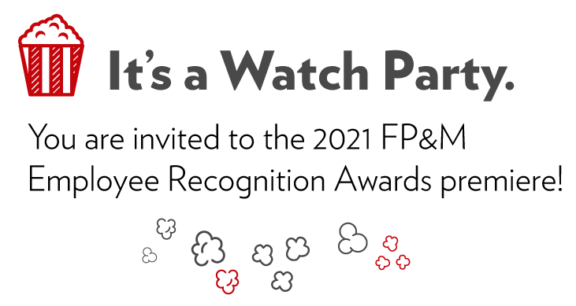Hello Staff,

Each year FP&M holds an Employee Recognition Awards celebration. As we transition to more in-person events, this year’s awards will be announced as an online premiere event. Let’s watch as a team! Join either onsite (details coming soon) or via your computer remotely.
Popcorn will be available to pick up ahead of time at _<<Specify popcorn location >>_. When it’s time for our watch party, please join the Teams meeting via the link below. Our team will be able to chat in the Teams meeting while watching. We can say a quick “hello” afterward too.
FP&M’s employee recognition program celebrates the unique contributions of FP&M staff. This is an initiative that came about based on employee feedback as a result of past Engagement, Inclusion and Diversity (EID) surveys.

Thank you to everyone who nominated our colleagues for an award, and to the FP&M Employee Recognition Team for making this possible. Looking forward to seeing who wins!
Note: if for some reason you cannot attend at this time, please view the Premiere later/independently. (The video link will be active on 7/22/21 at from 10:00am, onward)

Thanks,

<<Director/Supervisor Name>>

